Sponsorship Information
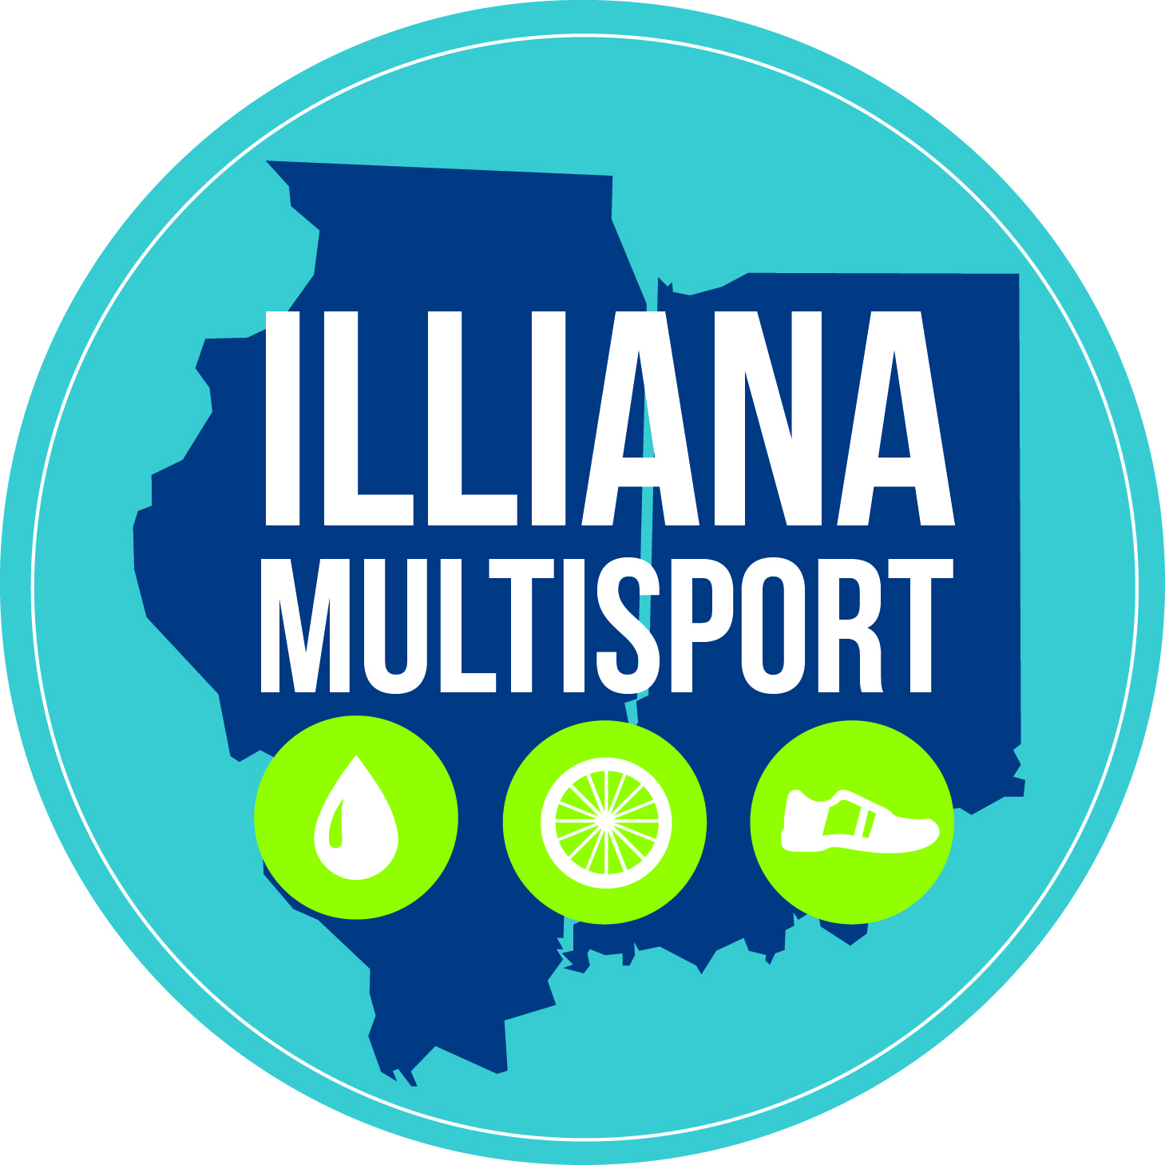
Thank you for your interest in becoming a sponsor of Illiana Multisport Team. Our mission is to inspire local multisport athletes in Illinois and Indiana. Currently, our team has more than 80 members from Crawford, Clark and Vigo counties. We are hopeful to gain more members as we grow and encourage a healthy lifestyle throughout the Illiana region. We strive to promote healthy lifestyles for all levels of interest, ability, and experience in the multisport arena. Our goal is to impact our communities and promote membership camaraderie, athletes’ safety on the roads, and overall healthy lifestyles.
Illiana Multisport Team is a registered USA Triathlon Club (USAT Club). As a USAT Club, we participate as a team and individually in triathlon, duathlon, and aquabike events. Besides competing, we reach out to the community, coordinating virtual races like Race for Rhett, and donating to Harmony Park. Many team members also lent a hand in the Run/Walk for Jenna that took place in Illinois. All team members volunteer at events as well as successfully manage the Crawford County Triathlon that takes place in August in Robinson, IL. With the local triathlon, we want to continue to promote use of our local resources and community. The proceeds from the event will be donated back to the community.
We have two types of sponsors: service and corporate sponsors. Our service sponsors provide discounts for items related to performance in events. Corporate sponsors assist us in paying for our training events and allow us to provide more impact in our communities.
Our training locations include indoor swimming at Lincoln Trail College and Indiana State University, outdoor swimming at Lincoln Trail State Park (Illinois) and Hawthorn Park (Indiana), indoor biking at Robinson Smile Center (aka The Pain Cave) in Illinois and the SRC at Indiana State University. We hope to continue to grow our impact in our communities by giving back. Corporate sponsorship would help us grow a future scholarship fund, include more community training sessions, and involve more local businesses to maintain and support the great wellness programs in our communities.

Some 2016 highlights include:
Participation in local events throughout Indiana and Illinois.
Volunteering at events in Indiana and Illinois.
Massive team participation in the USAT Mideast Regional Triathlon.
Participation in Ironman events in Indiana, Michigan, Texas, Colorado, Idaho, Kentucky and Hawaii.
Virtual race fundraiser – Race for Rhett.
Local run/walk fundraiser – Run/Walk for Jenna.
USAT Junior National Championship participation (Case Colvin).
Age Group National Champion (Martha Whitacre).
Stan Strohm qualified and participated in the 2016 IRONMAN World Championship in Kona, HI
Vaughn Rightly has qualified for the 2017 IRONMAN World Championship in Kona, HI
As we continue to grow into the future, we will hold true to our value and mission statement to impact our communities and promote health and wellness as well as help our participants/ members reach their optimal potential.
Our goal is to individualize our contracts with our corporate sponsors so that you feel well represented and our organizations can mutually benefit from this relationship.
Service Sponsorships
Guaranteed logo representation on tri kit and warm up
Monthly representation on social media
Corporate Sponsorships
$200 Logo Representation on our website
$500 Logo Representation on our website and uniform
$1,000 Logo Representation on our website and uniform along with social media interactions
All other promotional items, events, or benefits will be on an individual sponsorship basis.

*sizes of sponsorship logos may be adjusted according to number of sponsors.
Your sponsorship supports the following activites:
Where will my sponsorship money be used?
Indoor cycle training in Illinois and Indiana 1-2x per week
Indoor Swim training in Illinois and Indiana 2x per week
End of the year awards party
Purchase memberships for our swim coaches since they volunteer their services
Develop programs for future growth including youth development
Purchase USAT club membership
Purchase 5 million dollar liability insurance policy for our club

We hope that you will be joining us this year as a sponsor of Illiana Multisport Team. We are glad to answer any questions that you have. We have listed below the contact information as well as our previous sponsors for the 2016 season.
Contact information
Website: http://www.illianamultisport.com
Facebook: Illiana Multisport
Twitter: @TeamIlliana
General Email: illianamultisport@gmail.com

